Email Listener: The email listener monitors the email account on the configured folder and routes the email message to email service rule for processing

App Password:
We are creating an App Password to use it as the sender and receiver password in the Email Account.

- Open Gmail Account Click on Manage your Account

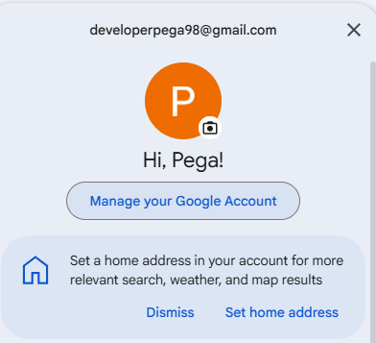

2.Go to Security and Sign in

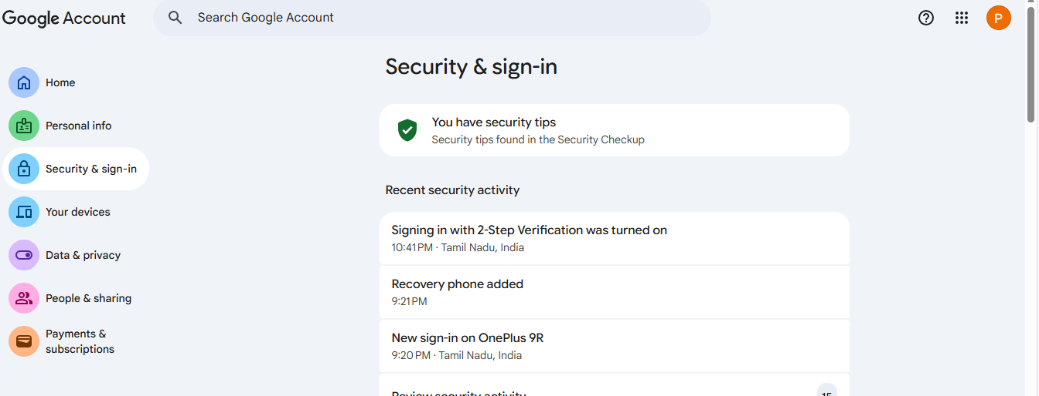

3. 2- Step Verification verification is Off we need to on a 2-Step Verification

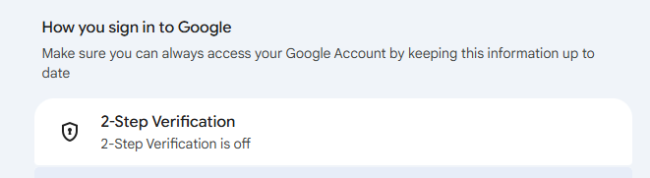

4. To turn on 2-Step Verification, we need to complete at least two verification steps.

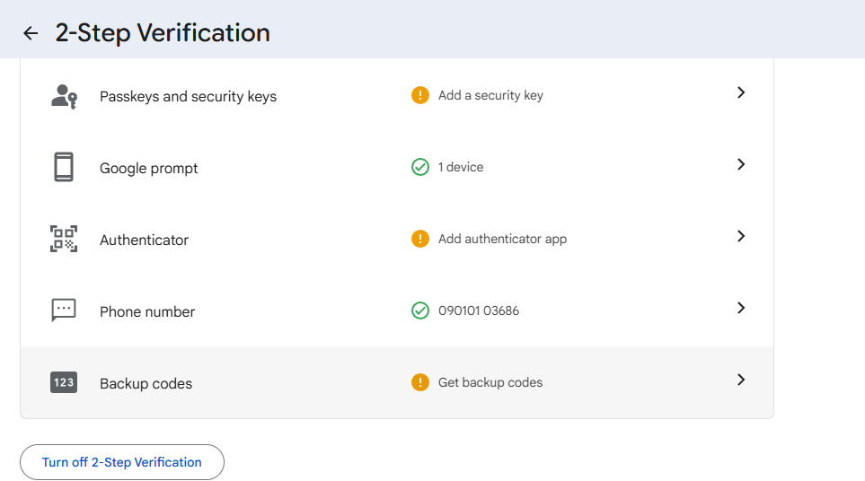

5. After turning on 2-Step Verification, it looks like the image shown below.

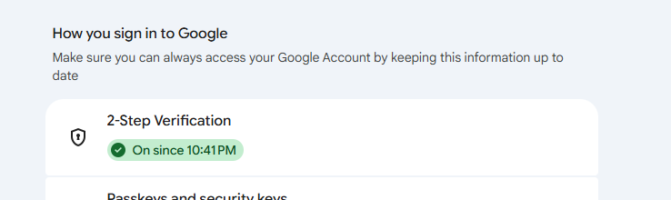

6. In Google Account Search Enter a App Password

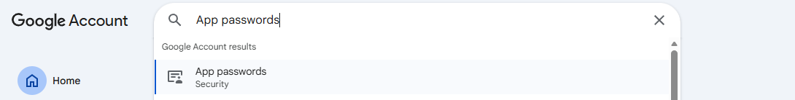

7. Enter App Name anything

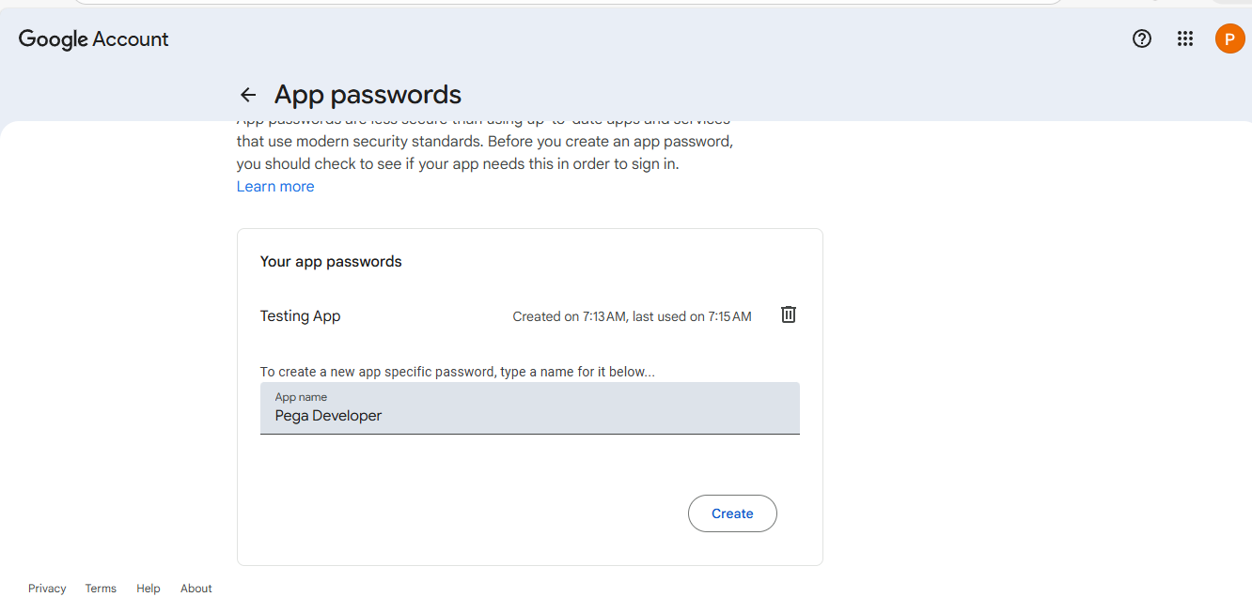

8. Click on Create it will generate a App password we can use this password in the sender and receiver password in the Email Account.

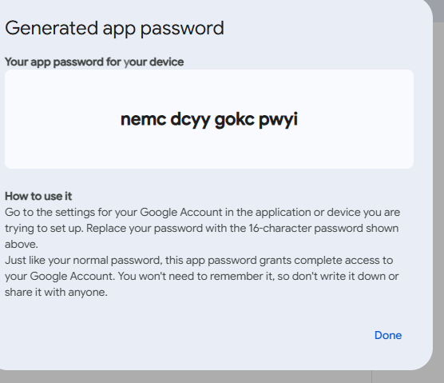

Email Account : Sample Email
Records Integration Resource Email Account
In Account Provider Select Google Gamil

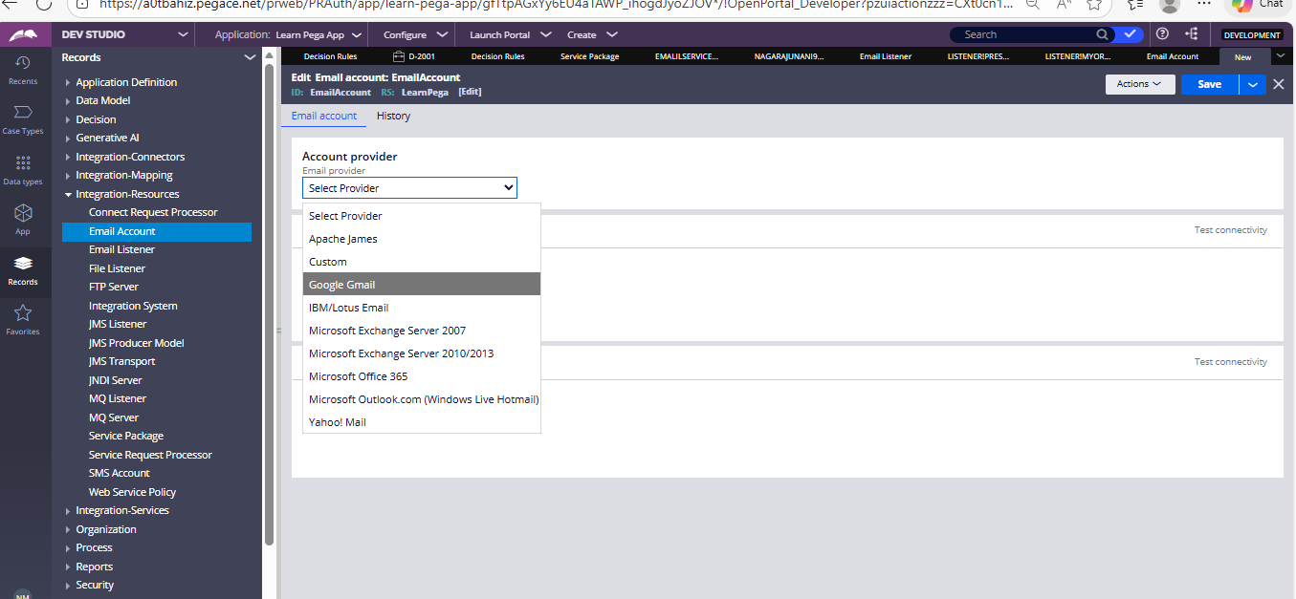

In Sender using Select SMTP

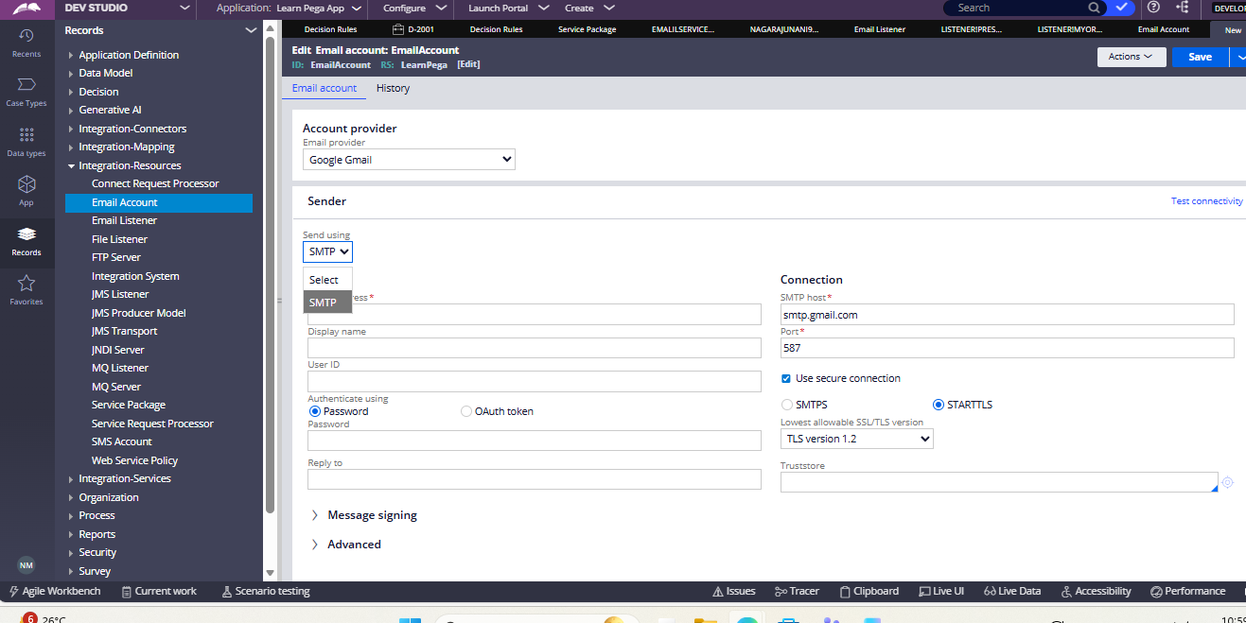

Give the Gmail id : developerpega98@gmail.com
Password: nemc dcyy gokc pwyi ( App Password)

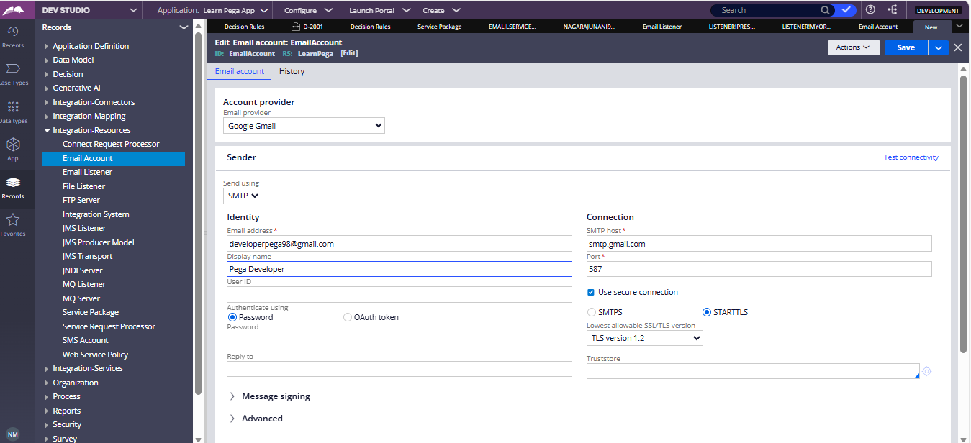

In Receviver Select POP3

Give the Gmail id : developerpega98@gmail.com
Password: nemc dcyy gokc pwyi ( App Password)

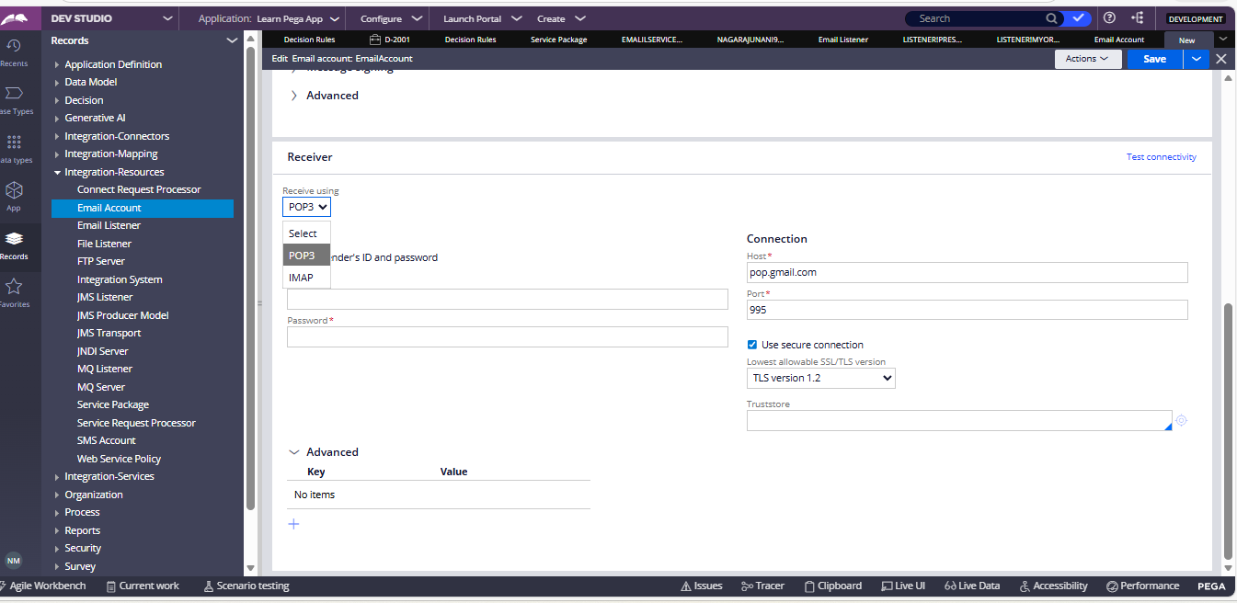

Email Account: Customer EmailAccount

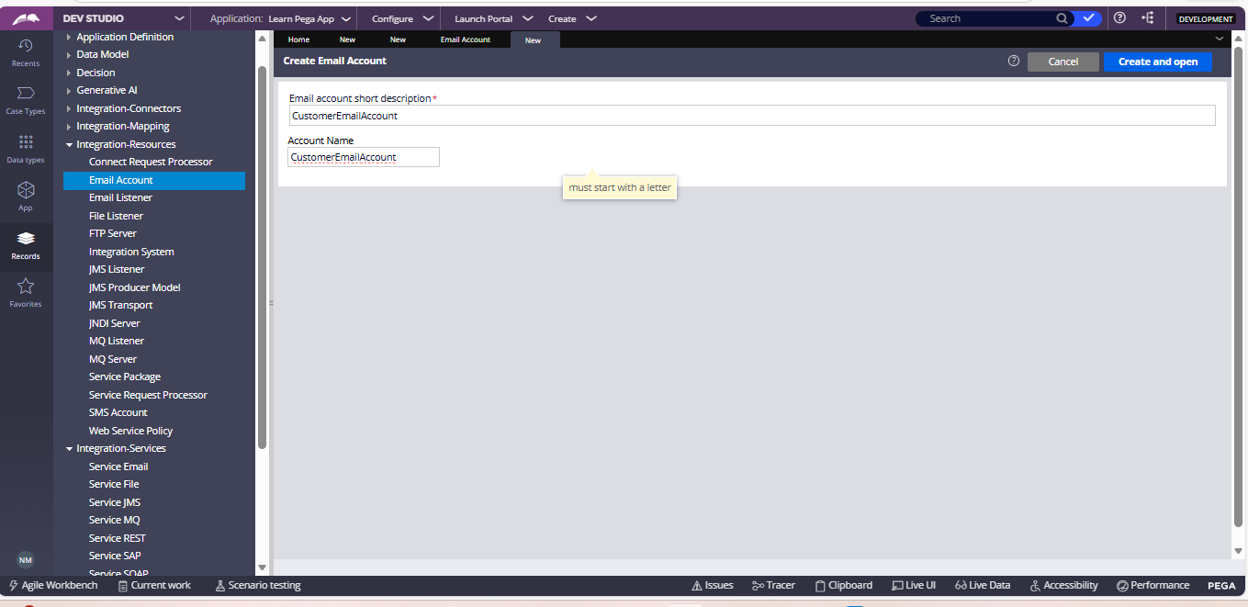

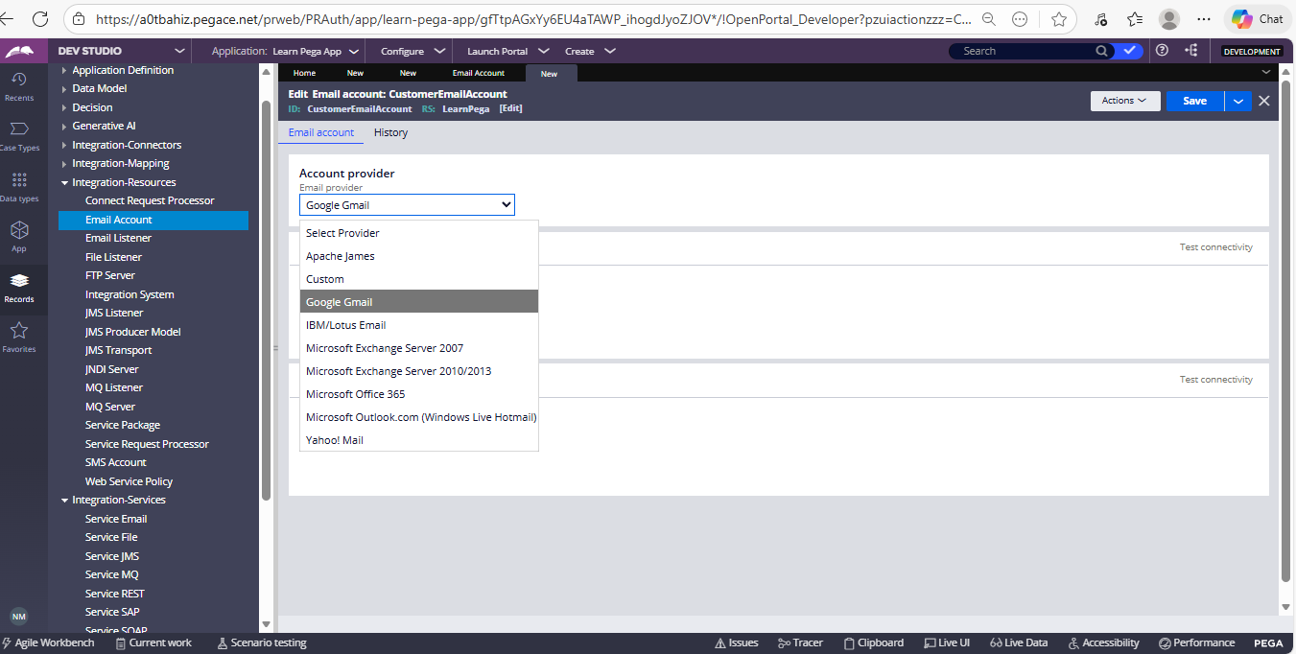

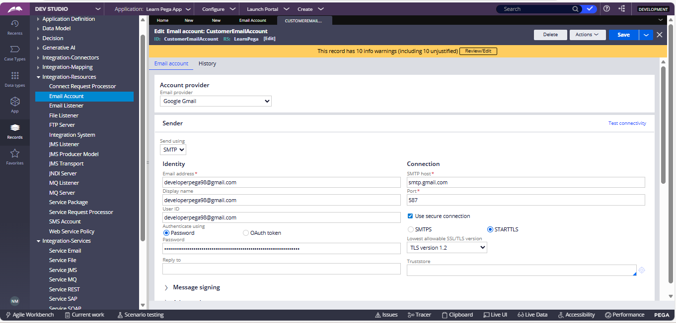

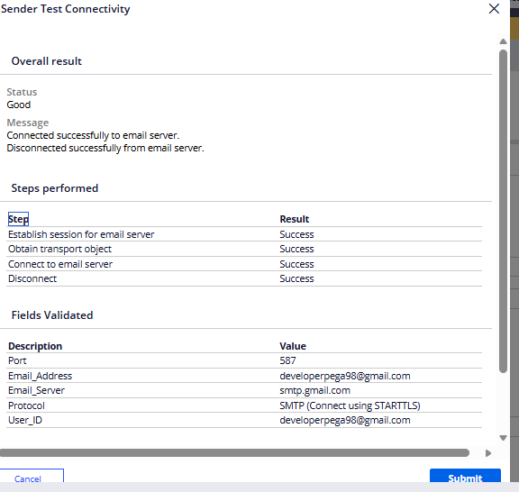

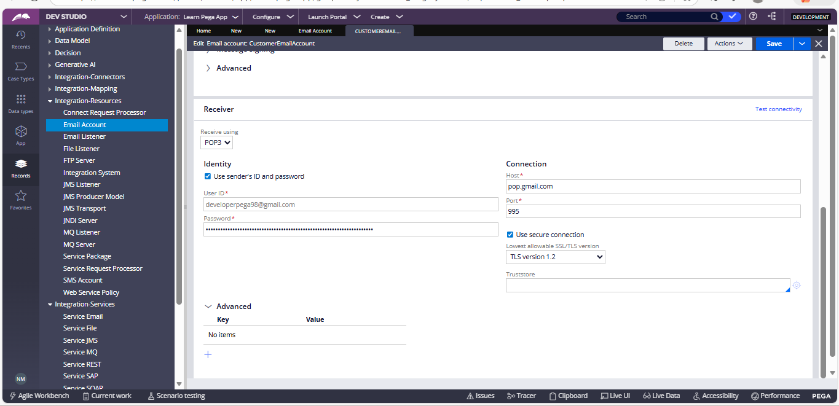

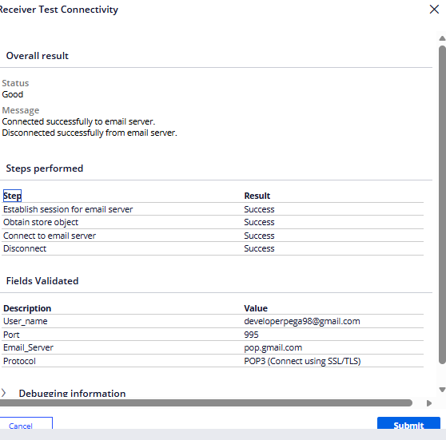

Case Type
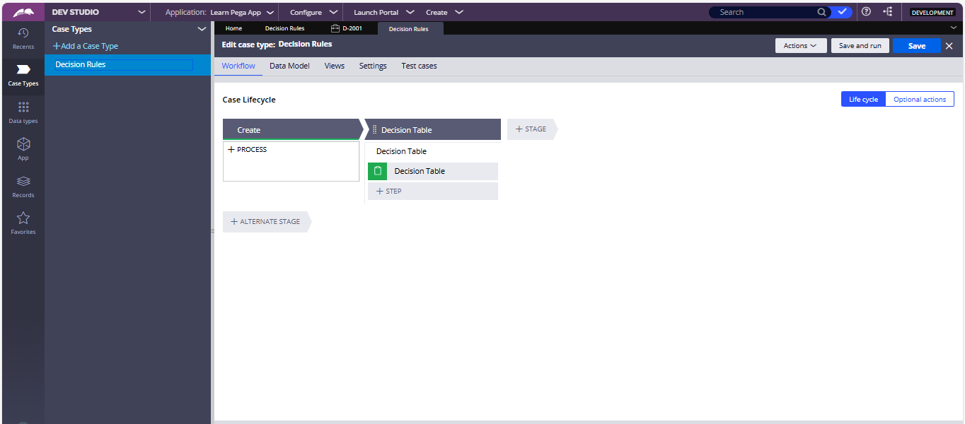

Create A Servive Package : Customer ServicePackage

RecordsIntegration ResourcesService Package
Based on business requirement we can select a Authentication we are selecting a without authentication
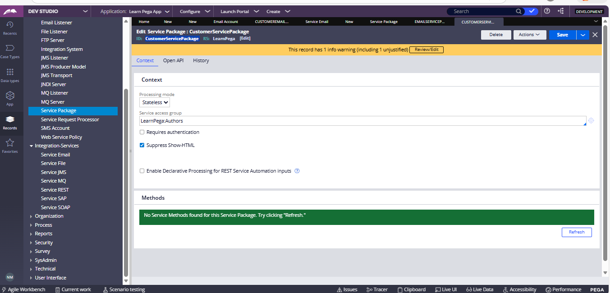

Servicve Email: CustomerServiceEmail
RecordsIntegration ServiceService Email

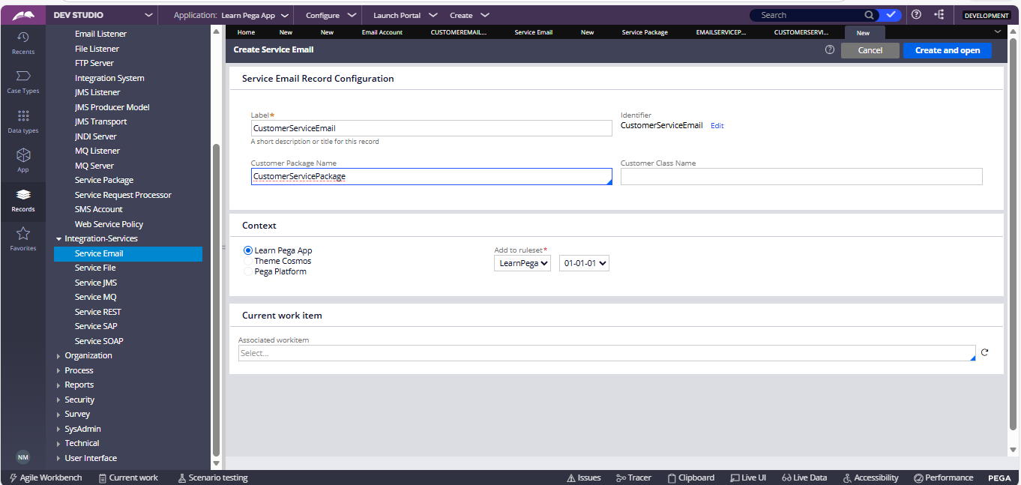

In Service Email we are calling a Activity : pyCreateAndManageWorkFromEmail

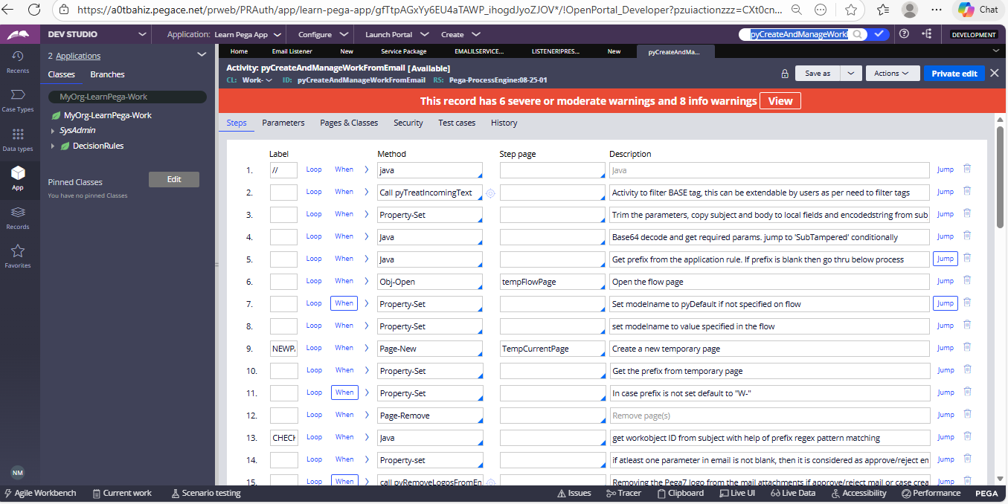

In Service Email Request Tab we are Mapping the Fields based on a business requirement

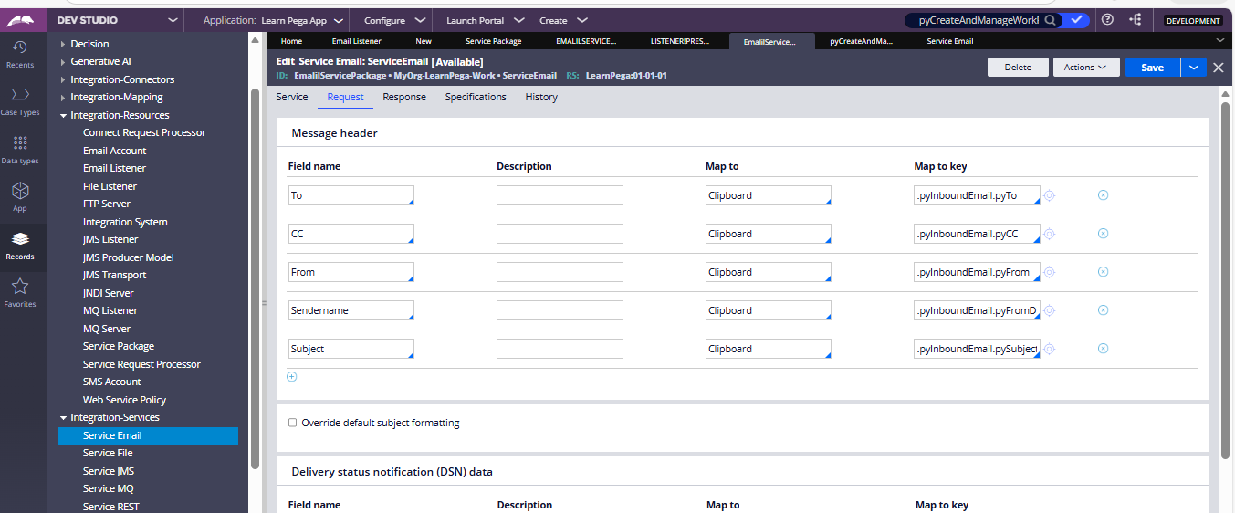

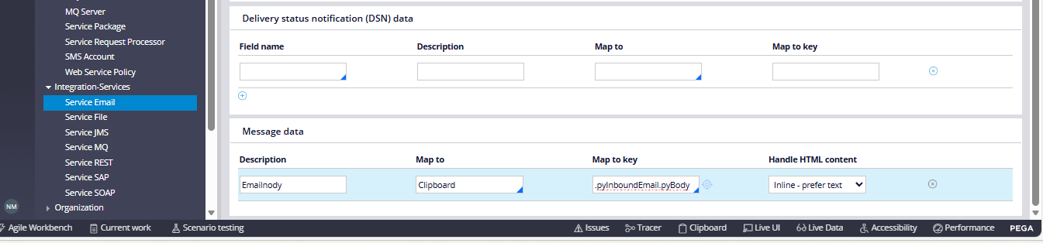

Email Listener : CustomerEmailListener
RecordsIntegrationResourcesEmailListener
In this EmailListener we are calling the ServicePackage and Service Method

